**Experiment 1.** **Unipolar Binary Coded 4 bit DAC**

-UREF = 5 V

UOUT = 4 V at full scale

UREF / UOUT = Rin / R9

5V/4V = 10kΩ / R9

R9 = 8kΩ

**1.1 Static Transfer Characteristic**

|  |  |  |  |  |
| --- | --- | --- | --- | --- |
| **I3** | **I2** | **I1** | **I0** | **Uout (V)** |
| **0** | **0** | **0** | **0** | **0.0016** |
| **0** | **0** | **0** | **1** | **-0.2477** |
| **0** | **0** | **1** | **0** | **-0.4970** |
| **0** | **0** | **1** | **1** | **-0.7466** |
| **0** | **1** | **0** | **0** | **-0.9966** |
| **0** | **1** | **0** | **1** | **-1.2460** |
| **0** | **1** | **1** | **0** | **-1.4955** |
| **0** | **1** | **1** | **1** | **-1.7451** |
| **1** | **0** | **0** | **0** | **-1.9946** |
| **1** | **0** | **0** | **1** | **-2.2439** |
| **1** | **0** | **1** | **0** | **-2.4933** |
| **1** | **0** | **1** | **1** | **-2.7429** |
| **1** | **1** | **0** | **0** | **-2.9929** |
| **1** | **1** | **0** | **1** | **-3.2430** |
| **1** | **1** | **1** | **0** | **-3.4920** |
| **1** | **1** | **1** | **1** | **-3.7410** |

**1.2 Transient Characteristic**

L/H transition of op-amp output:

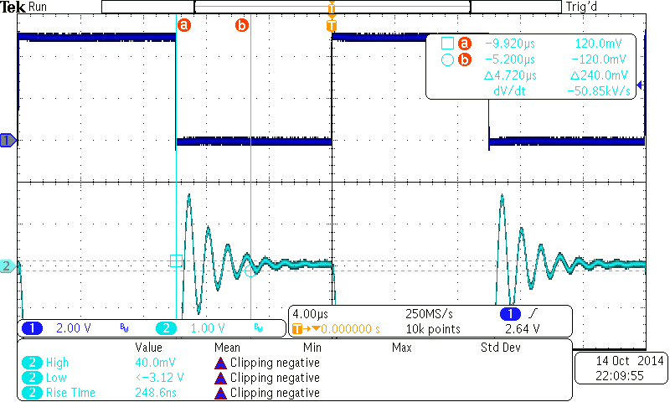

The “settling time” of the op-amp from Low to High transition is **∆t=4.720μs**

H/L transition of op-amp output:

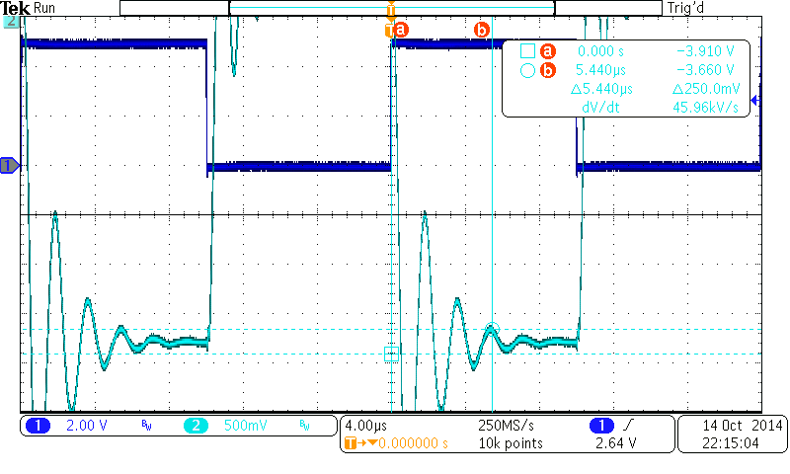

The “settling time” of the op-amp from High to Low transition is **∆t=5.440μs**

**Experiment 2. Unipolar Binary Coded 4 bit ADC**

**2.1 The measurement was made with the oscilloscope**

|  |  |  |  |  |
| --- | --- | --- | --- | --- |
| **I3** | **I2** | **I1** | **I0** | **Uout (V)** |
| **0** | **0** | **0** | **0** | **-0.16** |
| **0** | **0** | **0** | **1** | **-0.44** |
| **0** | **0** | **1** | **0** | **-0.64** |
| **0** | **0** | **1** | **1** | **-0.88** |
| **0** | **1** | **0** | **0** | **-1.12** |
| **0** | **1** | **0** | **1** | **-1.38** |
| **0** | **1** | **1** | **0** | **-1.66** |
| **0** | **1** | **1** | **1** | **-1.88** |
| **1** | **0** | **0** | **0** | **-2.12** |
| **1** | **0** | **0** | **1** | **-2.36** |
| **1** | **0** | **1** | **0** | **-2.64** |
| **1** | **0** | **1** | **1** | **-2.88** |
| **1** | **1** | **0** | **0** | **-3.08** |
| **1** | **1** | **0** | **1** | **-3.34** |
| **1** | **1** | **1** | **0** | **-3.60** |
| **1** | **1** | **1** | **1** | **-3.84** |

**2.2 Transient Characteristic**

The input voltage is varied from 0 to -4V

Uin=0V

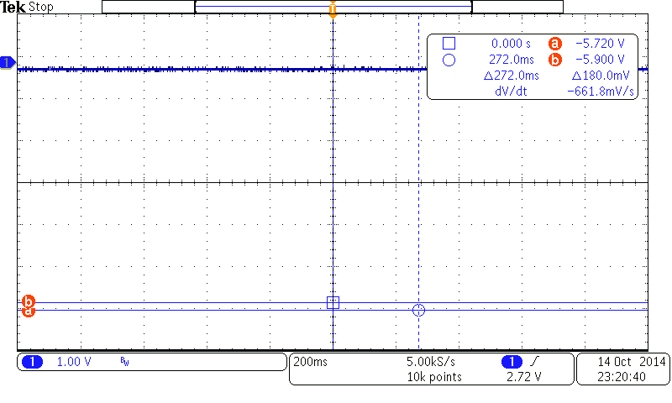

Uin= -1V

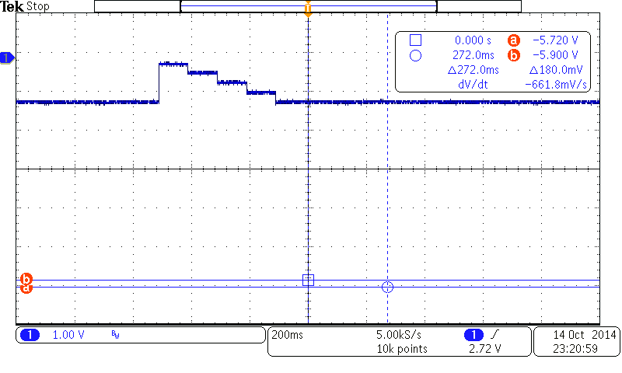

Uin= -2V

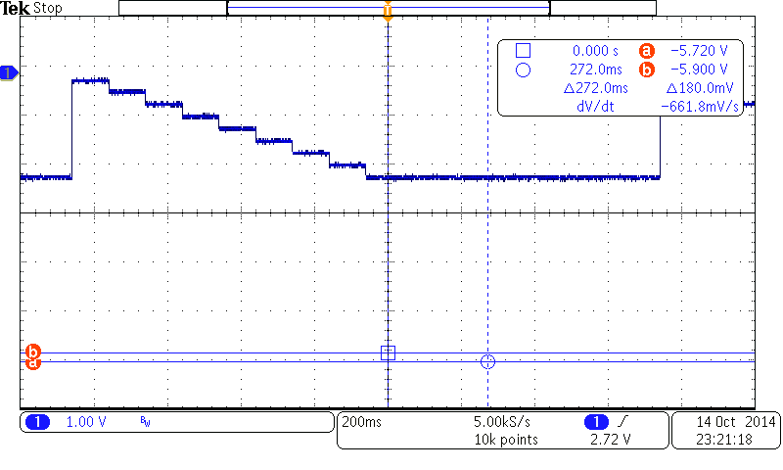

Uin= -3V



Uin= -4V

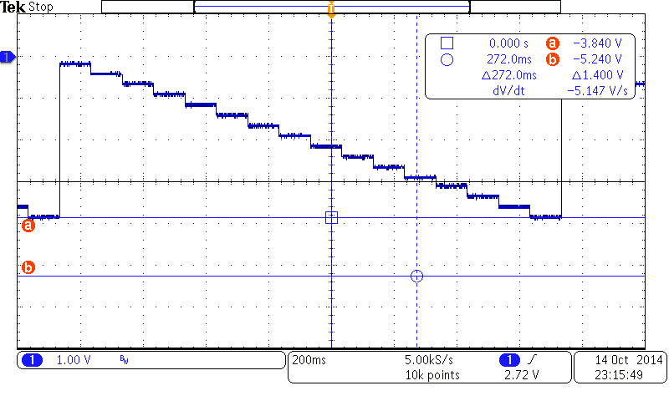

The largest glitches are seen at full scale of the bits 1111 (HHHH) where Uin = -4V

**Evaluation**

**3.1 DAC**

**3.1.1 ESL Parameters**

UOUT = α + β.Z

α is the value of the output voltage with all switches closed

**α = 0.0016**

β is the slope of the regression line

β = (UZ=1 – UZ=0 + UZ=2 – UZ=1 + ... + UZ=15 – UZ=14) / 15 = **-0.24951 = β**

**3.1.2 Integral and Differential Nonlinearity(∆I, ∆D)**

U’OUT(Z) = [UOUT(Z) – α]. $\frac{U(LSBnom)}{β}$

ULSBnom = 0.250V – nominal voltage of one quantum

∆IFS(Z) = (U’OUT(Z) – Unom(Z)) / UFS

∆DFS(Z) = [(U’OUT(Z) - U’OUT(Z-1)) - ULSBnom ] / UFS

|  |  |  |  |
| --- | --- | --- | --- |
| Z | U’OUT(Z) (V) | ∆IFS(Z) | ∆DFS(Z) |
| 0 | 0 | 0.000000 |  |
| 1 | 0.2498 | -0.000052 | -5.1769E-05 |
| 2 | 0.4996 | -0.000104 | -5.1769E-05 |
| 3 | 0.7497 | -0.000080 | 2.3379E-05 |
| 4 | 1.0002 | 0.000043 | 1.2358E-04 |
| 5 | 1.2501 | 0.000017 | -2.6719E-05 |
| 6 | 1.5001 | 0.000015 | -1.6700E-06 |
| 7 | 1.7502 | 0.000038 | 2.3379E-05 |
| 8 | 2.0001 | 0.000037 | -1.6700E-06 |
| 9 | 2.2499 | -0.000015 | -5.1769E-05 |
| 10 | 2.4998 | -0.000042 | -2.6719E-05 |
| 11 | 2.7499 | -0.000018 | 2.3379E-05 |
| 12 | 3.0004 | 0.000105 | 1.2358E-04 |
| 13 | 3.2510 | 0.000254 | 1.4863E-04 |
| 14 | 3.5005 | 0.000127 | -1.2692E-04 |
| 15 | 3.7500 | 0.000000 | -1.2692E-04 |
| 16 | 4 |  |  |





**3.2 ADC**

**3.1.1 ESL Parameters**